**Time Warped - Instructions**

4-6 Players | 7+ years old | 20-50 mins

**Escape the anomaly!**

In a world where time travel is commonplace, an anomaly in space time was discovered that connected many different time periods together within a loop of 12 hours. Many time travelers sought to examine it further, but once they reached it, it trapped them within the loop, which they soon found was extremely unstable. Trapped there for the foreseeable future, the time travelers eventually discovered that the ability to escape lay in calibrating their timepiece to each hour of the loop. Thus, a mad dash began as the time travelers raced to be the first one free in order to claim the discovery as their own!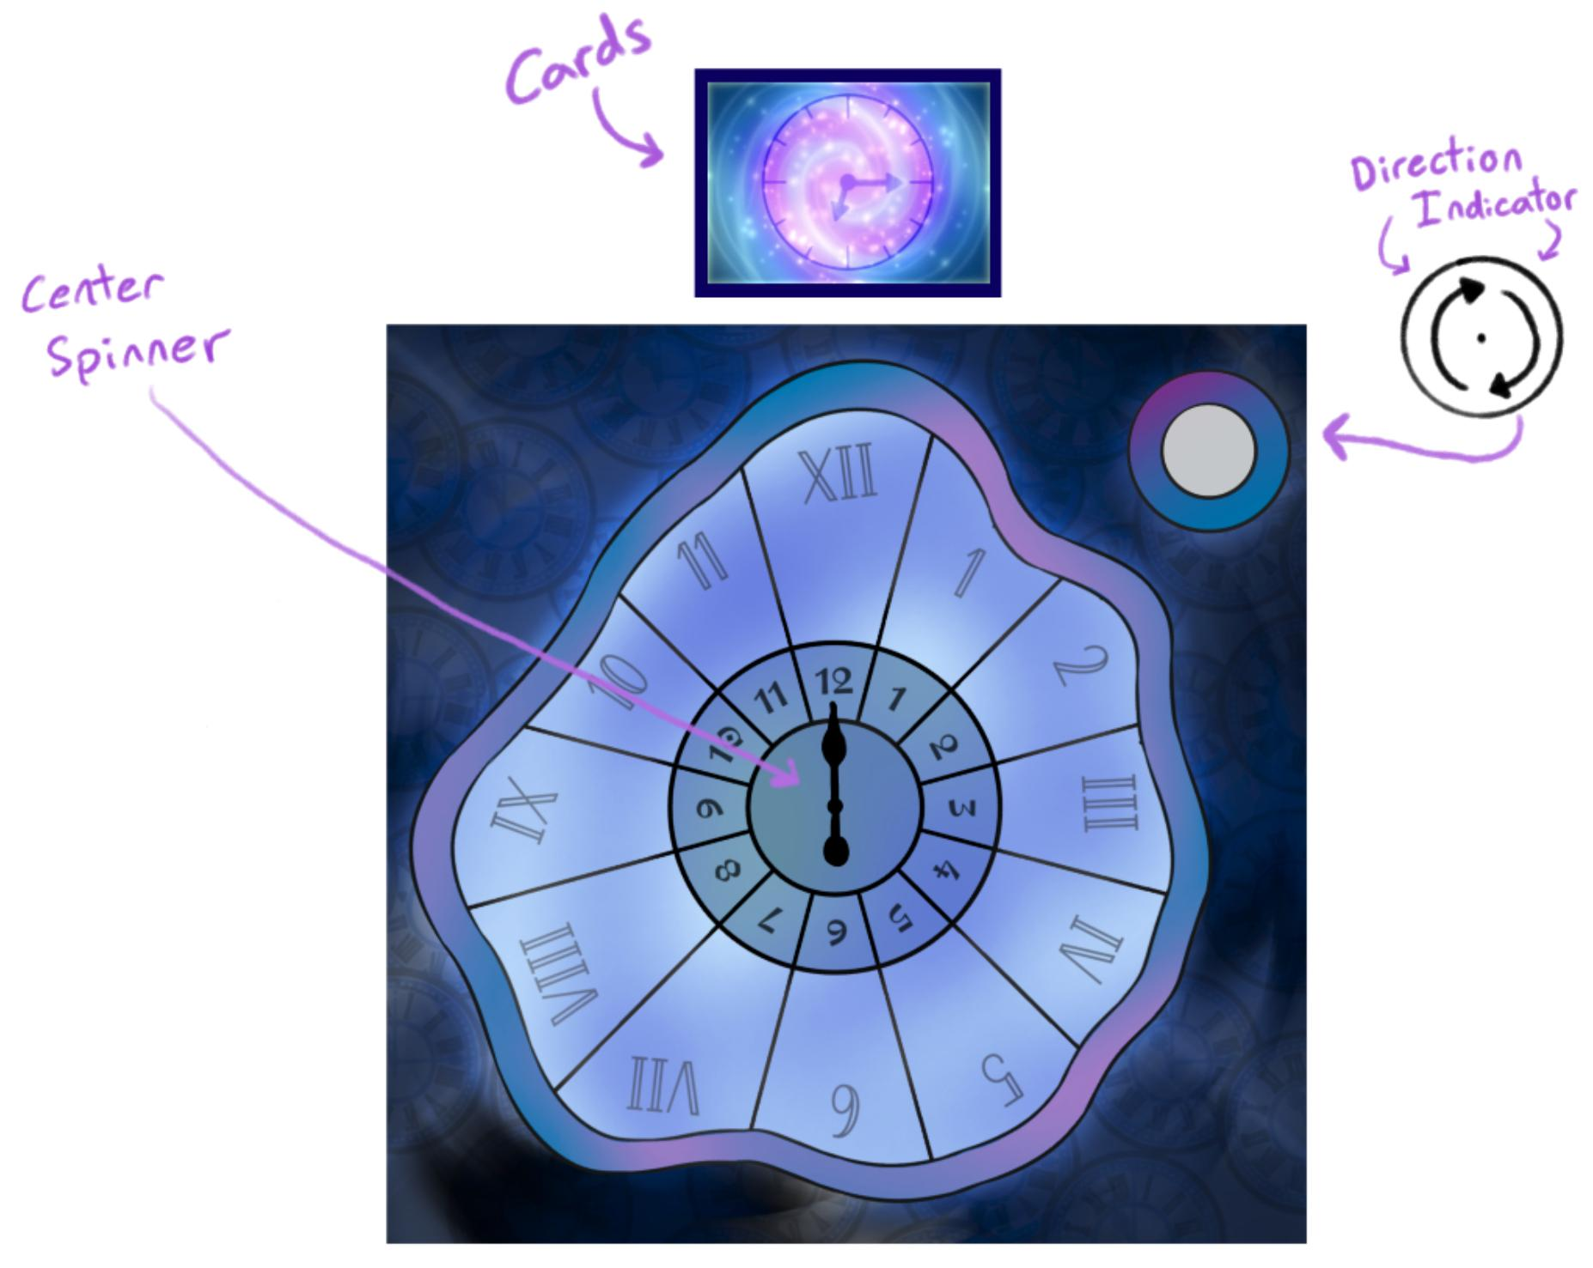

**Components**:

* + 1 board
  + 1 direction indicator
  + 1 spinner
  + 1 6-sided die
  + 6 player pieces
  + 6 player timepiece boards
  + 72 hour tokens
  + 80 cards

**Objective**: Be the first player to collect all 12 hours!

**Setup**:

1. Each player **select a player piece** and **corresponding timepiece board**
2. **Shuffle** the deck and deal 5 cards to each player to start
3. Make sure no players have a **Time Bomb** in their deck! If so, pick a new card and shuffle the **Time Bomb** into the draw pile.
4. Each player **spins the spinner** to determine your **starting space** on the board, this hour is **not collected**
5. Put the rest of the cards **face down** in draw pile(s)
6. Highest number on the spin goes **first** (in an event of a tie, roll for who goes first)
7. Player order is **clockwise** from starting player
8. Direction indicator starts **clockwise**

**How to play:**

1. Play a card from your hand:
   * + Movement cards: Move the indicated number of spaces
     + Action and Trap cards: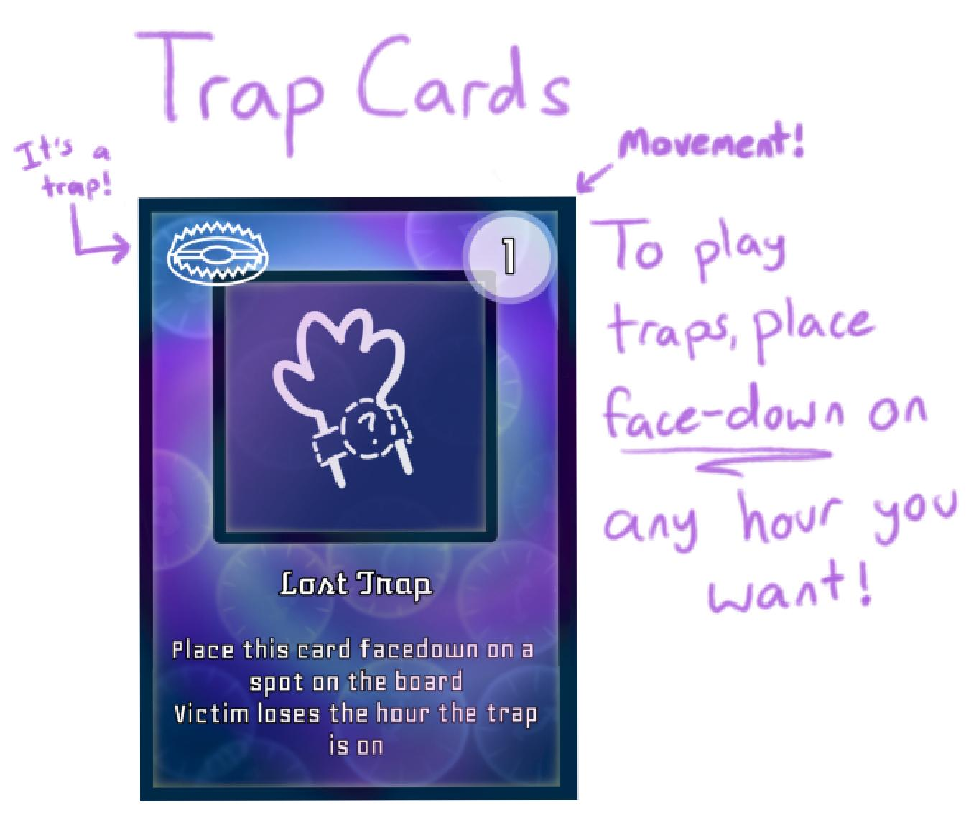

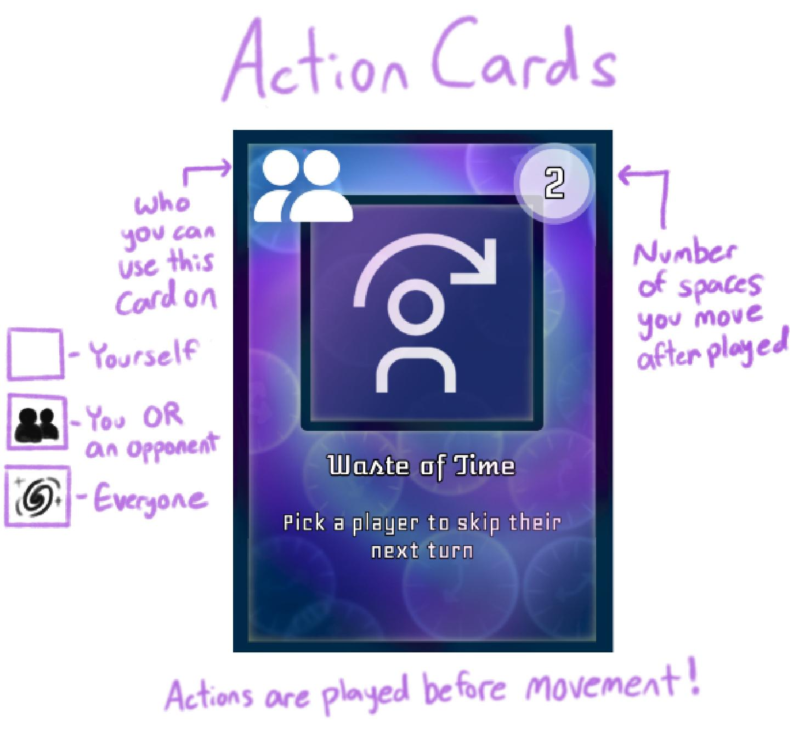

1. Follow the card descriptions
2. If you land on a space that you have not collected, collect the space unless specified otherwise
   * + **You can only collect hours during your own turn! Do not collect if you are moved by another player.**
3. Draw card(s) to return your hand to 5 cards, thus ending your turn
4. Move clockwise to next player

**Resolution**: Once a player has collected all 12 hour spaces, they have won the game, the rest of the players lost.

**Reference**: 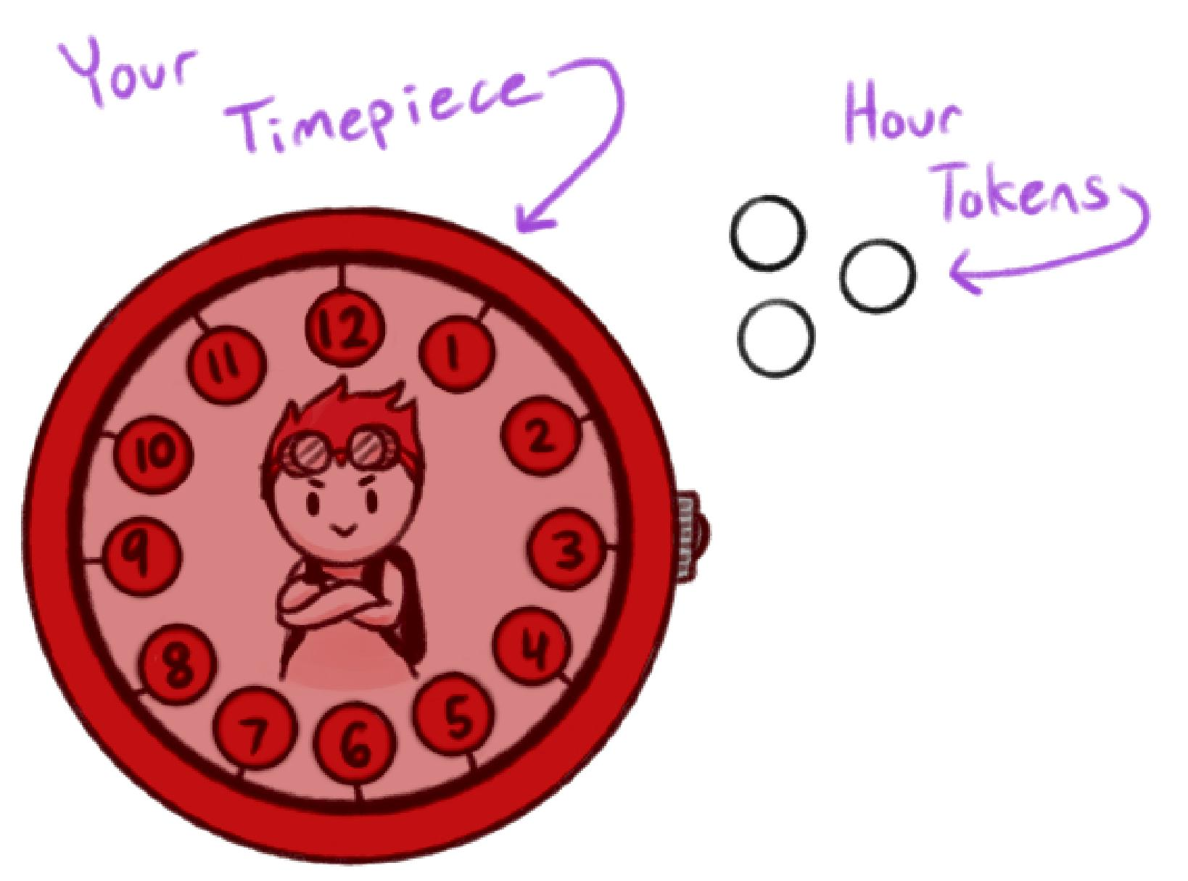

**Collecting an Hour**

You collect an hour when you land on a space on your turn. Put a token on the corresponding hour on your timepiece board. For example, if a player plays a 3 card when already on the 3 space, they move from 3 to 6. If the player hasn’t collected 6 before, now the player adds 6 to their collection.

**Losing a Turn**

Lost turns **do not stack**! If a player is already skipped, they cannot be skipped again until their lost turn has passed.

**Special Card Interactions**: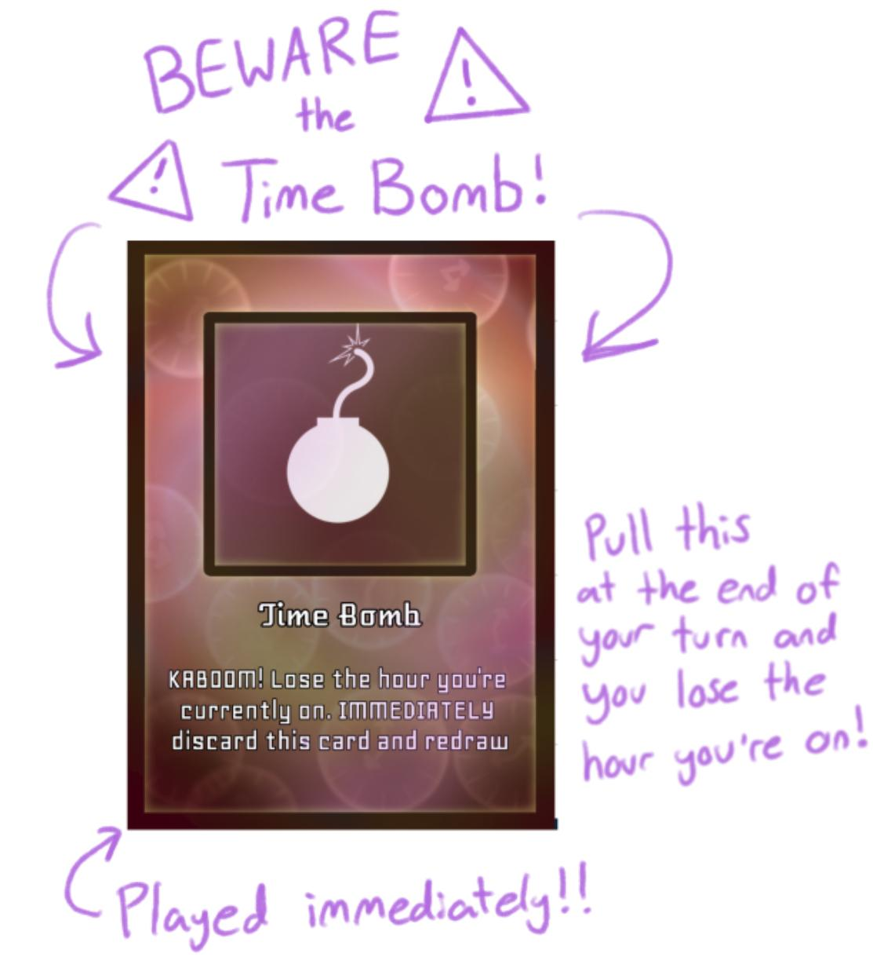

**Time Bomb**

If you draw a **Time Bomb** card, lose the hour that you are currently standing on, discard that card, and immediately draw another card.

**Trap Cards**

If you land on a **trap** card, you take the effect of the **trap** card, **not the hour the trap is on**.

~ OR ~

If you land on a **trap** card and have a **Temporal Bubble** card, immediately use and discard the **Temporal Bubble** card and draw a new one, you do not take the trap card's effect, you can **collect the hour**, and **the trap card is removed** from the board.

**Types of Trap Cards:**

* **Time Trap**: Victim loses a turn
* **Turn-Back Trap**: Sends the victim back to the space they were on before landing on the trap.
* **Hour Trap**: Victim has to spin the spinner and move to the corresponding space.
* **Lost Trap**: If the Victim already has the hour the trap is on, they lose it.